APPENDIX-I
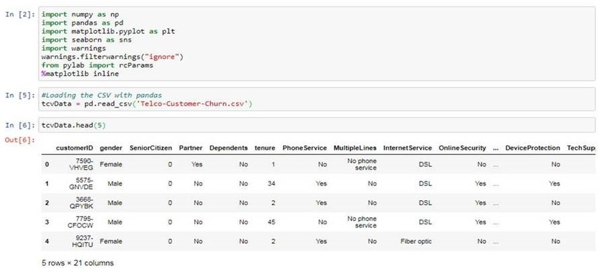

FIGURE 1
Declaring Python Libraries and reading the transaction data set file (Elance, 2020: Reworked)
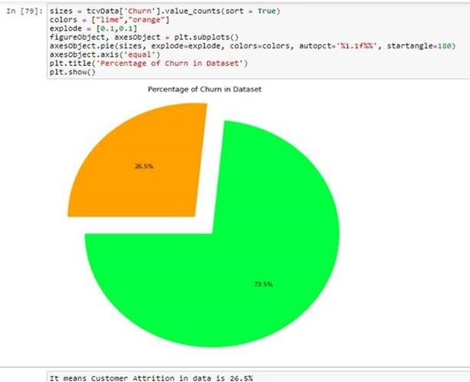

FIGURE 2
Determining Percentage of Churn in Dataset (Elance, 2020: Reworked)

Results of Logistic Regression
Table 1
WEIGHTING FACTORS OF TELECOM CUSTOMER CHURN (ELANCE, 2020)
Sl. No. | Variable | Weight
1 | PaperlessBilling | 0.38979
2 | Senior Citizen | 0.246504
3 | InternetService | 0.209283
4 | Partner | 0.067855
5 | Streaming Movies | 0.054309
6 | MultipleLines | 0.04233
7 | PaymentMethod | 0.039134
8 | MonthlyCharges | 0.02718
9 | StreamingTV | -0.008606
10 | gender | -0.029547
11 | tenuree | -0.034668
12 | DeviceProtection | -0.05269
13 | OnlineBackup | -0.143625
14 | Dependents | -0.209667
15 | OnlineSecurity | -0.245952
16 | TechSupport | -0.25474
17 | Contract | -0.729557
18 | PhoneService | -0.950555

